

**DEVELOPMENT OF MOBILE APPLICATION**

**FOR SEXUAL AND REPRODUCTIVE HEALTH**

**SYSTEM DESIGN DOCUMENT**

**VERSION 1.0**

**September 2022**

This publication was prepared by **Tanzania Mentors Action** **(TMA) located** in Dodoma in collaboration with the **WGNRR**

**SYSTEM DESIGN DOCUMENT FOR DEVELOPMENT OF**

**MOBILE APPLICATION FOR SEXUAL AND REPRODUCTIVE HEALTH**

**iii**

Table of Contents

ACRONYMS V

AUTHORSHIP AND REVISIONS VI

1.0 INTRODUCTION 1

**1.1 Purpose of the SDD** 1

**1.2 Scope** 1

2.0 DESIGN APPROACH 2

**2.1 Development Methods & Contingencies** 2

**2.2 Architectural Strategies** 2

3. DETAILED SYSTEM DESIGN 4

**3.1**  **Database design** 4

3.2 Data Dictionary 5

**3.3**  **Software Detailed design** 8

**3.3.1**  **Use case diagrams** 8

3.3.1.1 Super Admin Setup use case diagram 8

3.3.1.2 Admin setup use case diagram 9

3.3.1.3 Client use case diagram 10

3.3.1.4 Health Care provider use case diagram 11

3.3.1.5 Community based mobilizer use case diagram 12

**3.3.2**  **Activity Flow Diagrams** 13

3.3.2.1 Super Admin Activity Diagrams 13

3.3.2.2 App Admin Activity Flow Diagrams 20

3.3.2.3 Client Activity Flow Diagram 27

3.3.2.4 Health Care Provider Activity Flow Diagram 28

3.3.2.5 Community Based Mobilizer Activity Flow Diagram 29

**3.4**  **User Interface design** 30

**3.5**  **Appendix C: Approval** 36

List of Tables

Table 1:Table Activities 7

List of Figures

Figure 1 : Data Exchange for Sexual and Reproductive health 3

Figure 2: Database schema 4

Figure 3: Super Admin use case diagram 8

Figure 4: Admin use case diagram 9

Figure 5: Client use case diagram 10

Figure 6: Health Care provider use case diagram 11

Figure 7: Mobilizer Use case diagram 12

Figure 8: Super Admin feed configuration setup 13

Figure 9: Super Admin user management configuration setup 14

Figure 10: Super Admin Health Facility configuration setup 15

Figure 11: Super Admin Content configuration setup 16

Figure 12: Super Admin FAQs configuration setup 17

Figure 13: Super admin report configuration setup 18

Figure 14: Super Admin rating configuration setup 19

Figure 15: App Admin Feed setup configuration setup 20

Figure 16: App admin user management configuration setup 21

Figure 17: App admin health facility configuration setup 22

Figure 18: App admin configuration setup 23

Figure 19: App admin FAQs configuration setup 24

Figure 20: App admin rating configuration setup 25

Figure 21: App admin report configuration setup 26

Figure 22: Client Activity Flow diagram 27

Figure 23: Health Care provider Activity diagram 28

Figure 24: Mobilizer Activity flow diagram 29

Figure 25: Sample User interface design on SHR App 30

Figure 26: Admin Panel Interface design on SHR App 35

# ACRONYMS

TMA-Tanzania Mentors Action

WGNRR-Women Global Network for Reproductive Rights

UI-User Interface

WHO-World Health Organization

MoH-Ministry of Health

SRH-Sexual and Reproductive Health

SDD-System Design Document

PHP-Hypertext Preprocessor

HTTP-Hypertext Transfer Protocol

API-Application programming Interface

CRUD-Create/Read/Update/Delete

# AUTHORSHIP AND REVISIONS

|  |  |  |  |
| --- | --- | --- | --- |
| **Date** | **Document Version** | **Document Revision Description** | **Document Author** |
| September 2022 | v1 | The first draft was documented based on outcomes from the stakeholders’ workshop on user requirements for the Sexual and Reproductive Health Work session that was held on 14th  September 2022 at Ngome Complex Hall, Dar es Salaam. | Tanzania  Mentors Action (TMA) under contract with the WGNRR  Africa |
|  |  |  |  |
|  |  |  |  |

|  |  |  |  |
| --- | --- | --- | --- |
| **Approval Date** | **Approved Version** | **Approver Role** | **Approver** |
|  |  |  |  |
|  |  |  |  |

## 1.0 INTRODUCTION

Women’s Global Network for Reproductive Rights–Africa (WGNRR Africa) intends to facilitate access to Sexual and Reproductive Health information and services through online platform.

The online platform shall contain SRH information, such as Family planning, sexually transmitted infections/diseases, menstrual health and post-abortion care in alignment with the World Health Organization (WHO) and The Ministry of Health (MoH) guidelines; and will offer possibility to refer the patient to identified health facilities. The online platform shall be accessible via mobile application in both Android and IOS operating system.

To achieve this, TMA has been awarded a contract to develop Mobile App for addressing sexual and reproductive health (SRH) needs of women and therefore, the consultant engaged is expected to provide technical support and develop the application.

### **1.1 Purpose of the SDD**

The system design document tracks all the necessary information required to effectively define the architecture and system design to give the development team guidance on the architecture of the system to be developed. The Design document is incrementally and iteratively produced during the system development life cycle. Its intended audience is the project manager and development team. Some portions of this document, such as the user interface (UI), may be shared with the users and other stakeholders of whom their inputs/approval the UI is needed.

### **1.2 Scope**

This SDD covers functional and non-functional requirements. Non-functional requirements describe how the system works, while functional requirements describe what the system should do.

## 2.0 DESIGN APPROACH

### **2.1 Development Methods & Contingencies**

In development of the mobile application, the technical team has chosen Flutter, a free and open-source UI framework for creating native mobile applications from Google. The language has been chosen considering its capabilities, as it is free and open source, it is widely used; it is independent of platform and can run in Linux/UNIX, Windows and MacOS. Flutter Build, test and deploy native mobile, web, desktop and embedded apps from a single Codebase. It Controls every pixel to create customizable and adaptive designs that look great on any screen.

Further to enable the continuity and ease of maintaining the system, the technical team has chosen open-source server-side scripting language PHP framework for the backend of the project, together with PostgreSQL database management system a free and open-source relational database management system.

### **2.2 Architectural Strategies**

### 

The system uses RESTful API as a tool for communication with the database through HTTP requests to access and use data. That data can be used to GET, PUT, POST and DELETE data types, which refers to the reading, updating, creating and deleting of operations concerning resources. PostgreSQL REST API connection allows to create Restful applications with PostgreSQL as a database.

PHP's PostgreSQL extension provides a comprehensive API to interact with a PostgreSQL Relational Database Management System. In addition to basic SQL operations, the API also supports prepared statements, transactions, table metadata retrieval, and server variable inspection.

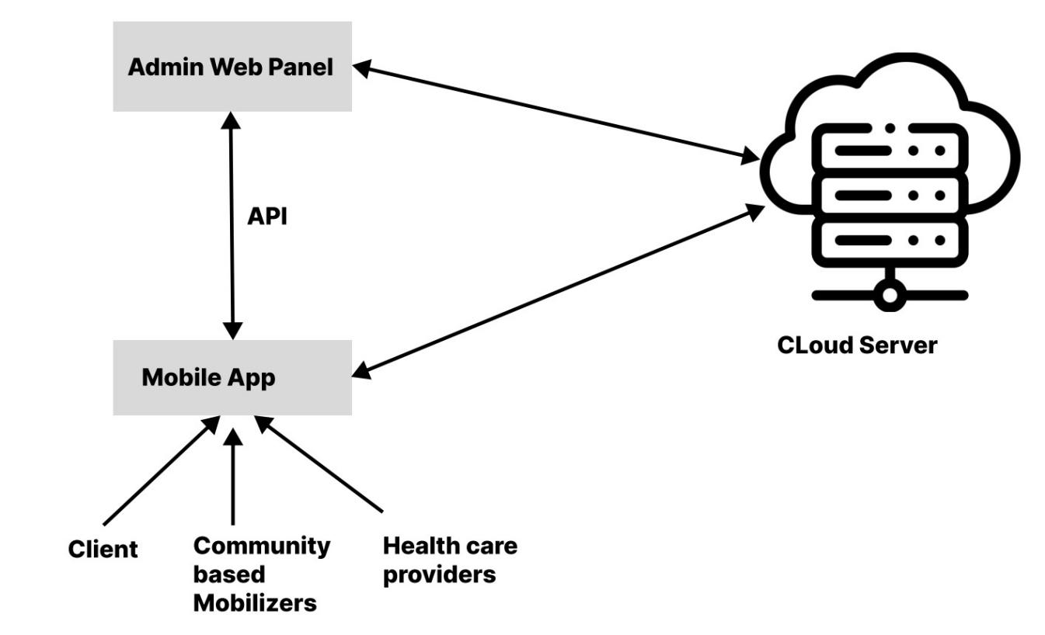

Figure 1 : Data Exchange for Sexual and Reproductive health

## 3. DETAILED SYSTEM DESIGN

### **3.1 Database design**

To ensure that the database adheres to the principles of Atomicity, Consistency, Isolation and Durability, the SHR technical team designed the schema of the database of the system as shown in Figure 2.

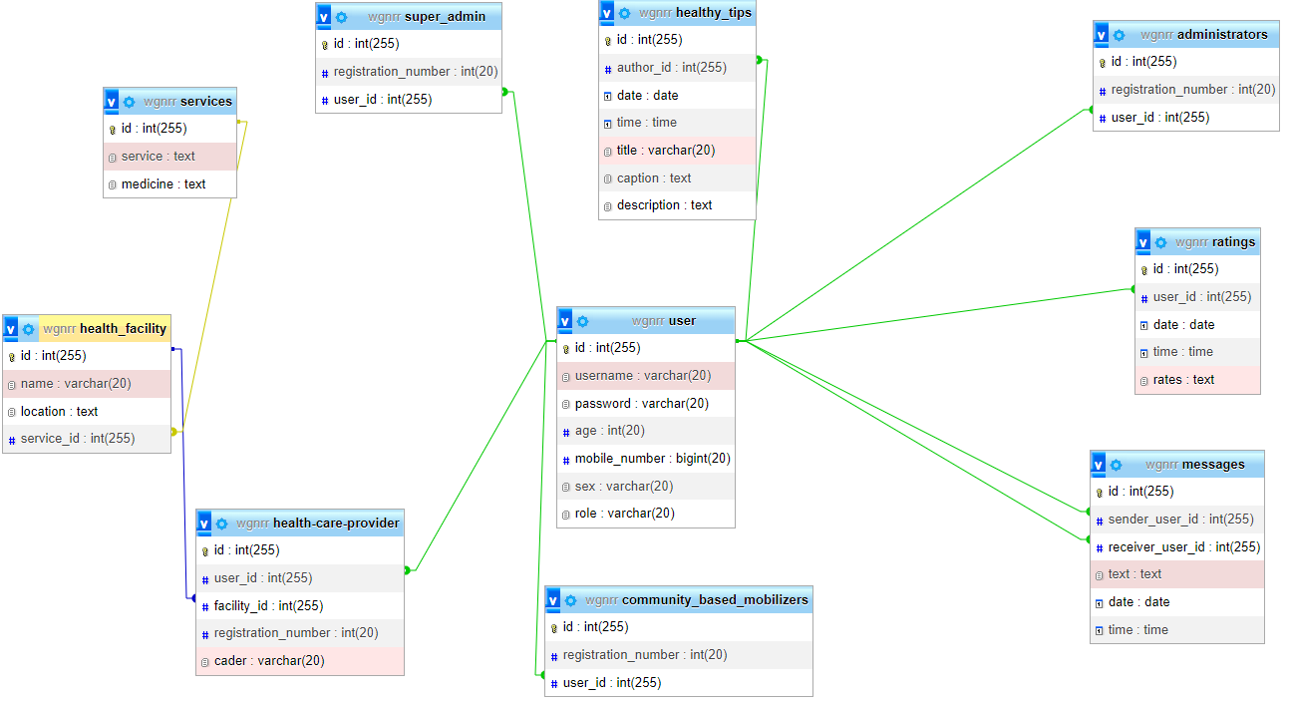

Figure 2: Database schema

### 3.2 Data Dictionary

A data dictionary contains a list of all files in the database, the number of records in each file, and the names and types of each field. Most database management systems keep the data dictionary hidden from users to prevent them from accidentally destroying its contents. Data dictionaries do not contain any actual [data](http://www.webopedia.com/TERM/D/data.html) from the database, only bookkeeping information for managing it. Without a data dictionary, however, a database management system cannot [access](http://www.webopedia.com/TERM/A/access.html) data from the database.

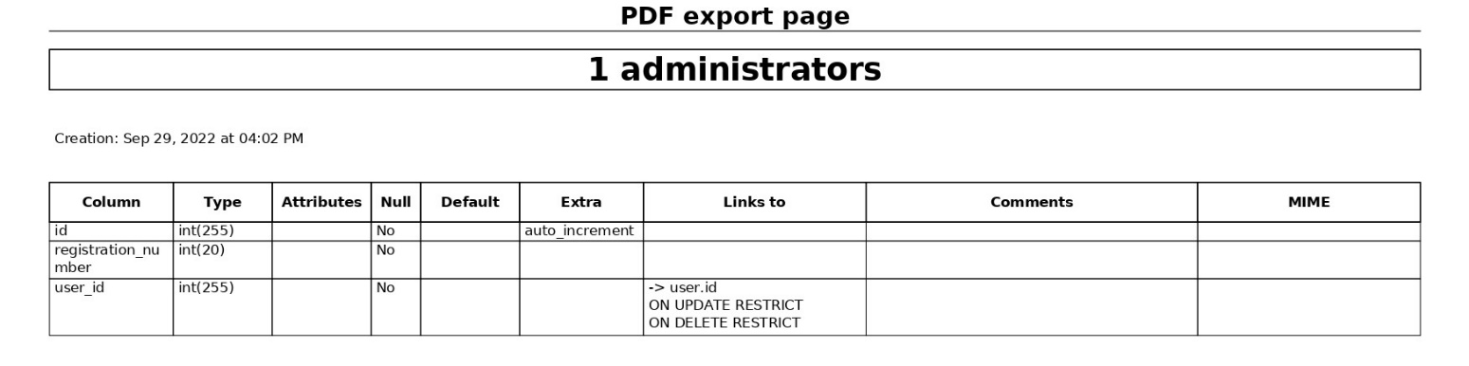

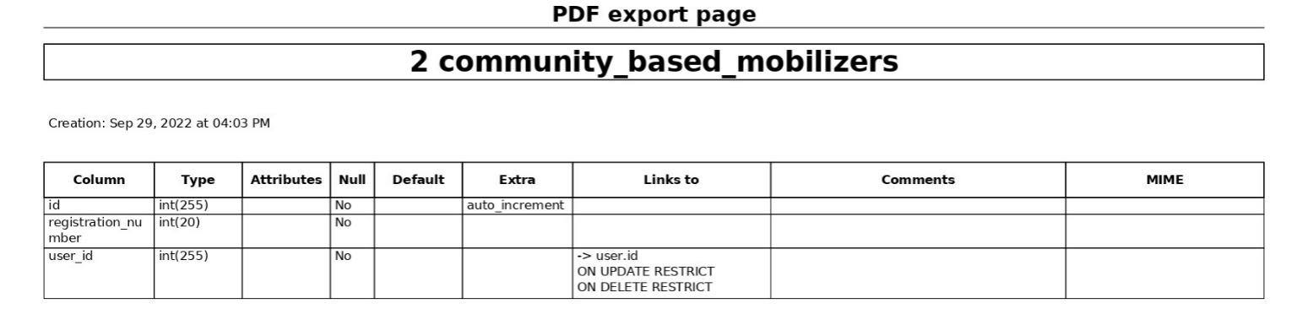

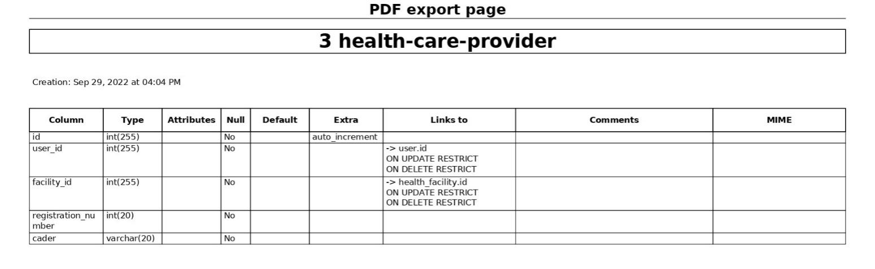

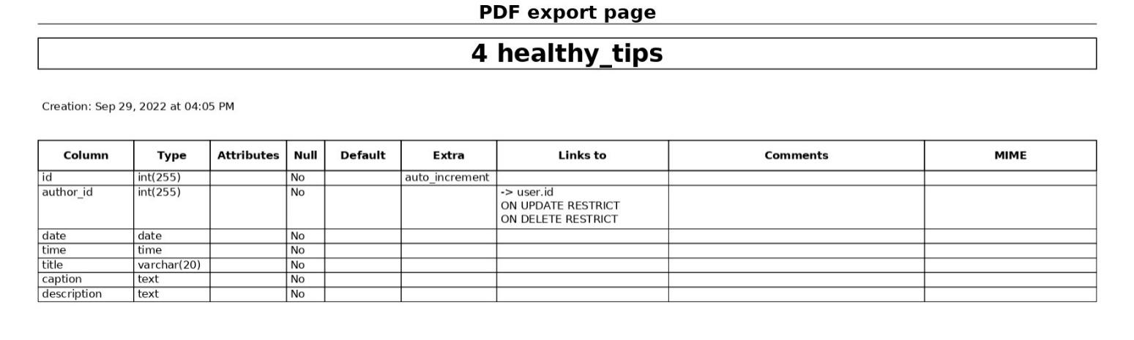

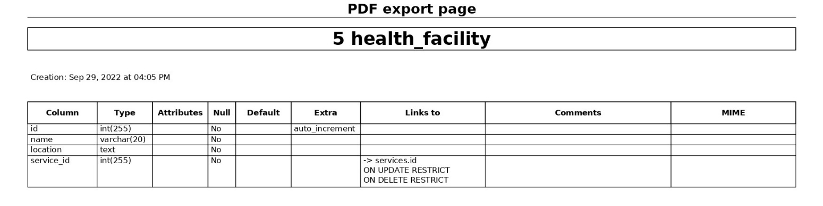

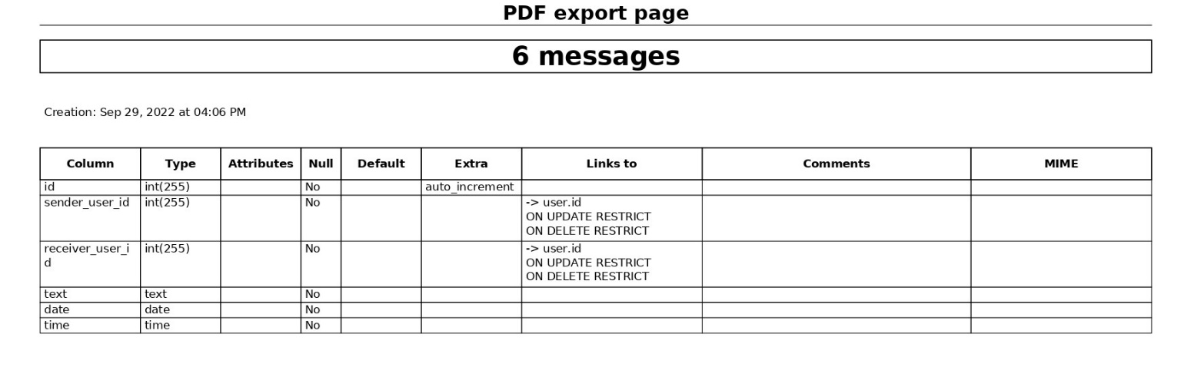

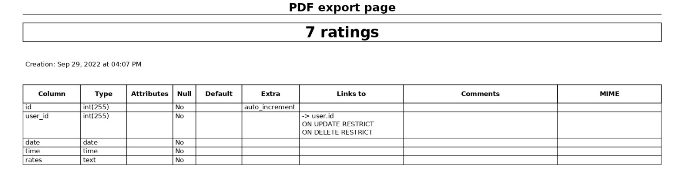

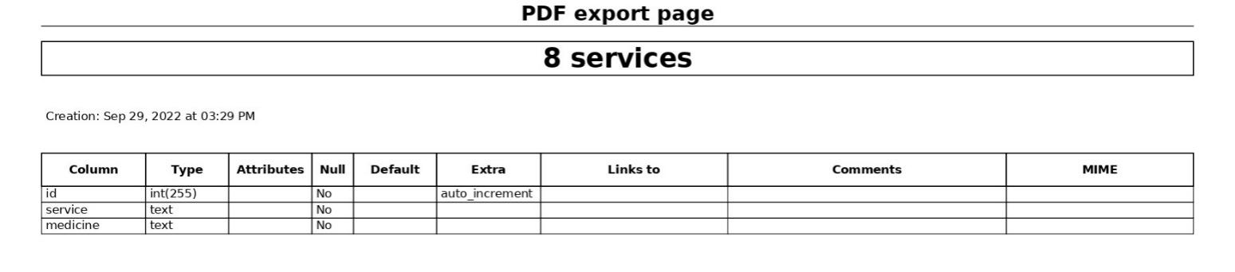

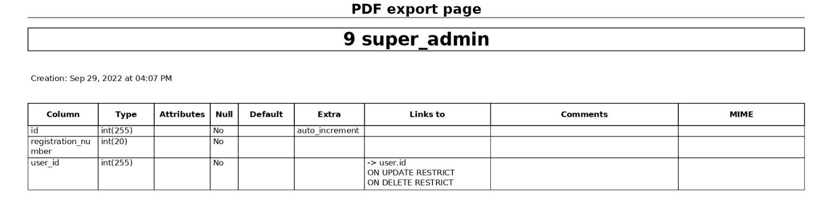

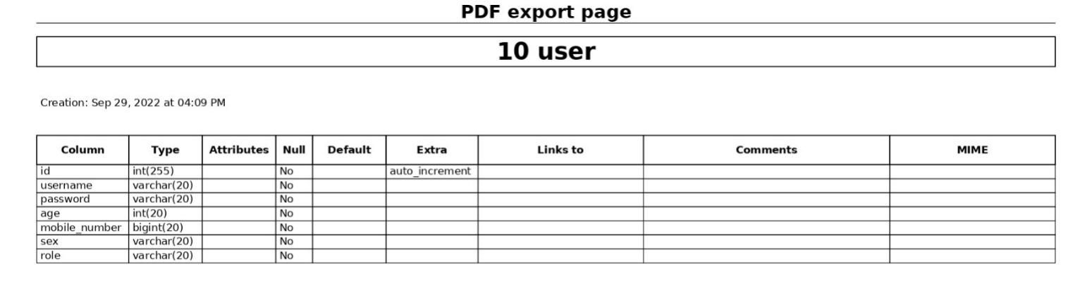

Table 1:Table Activities

### **3.3 Software Detailed design**

### **3.3.1 Use case diagrams**

Use case diagram is a representation of a user's interaction with the system that shows the relationship between the user and the different use cases in which the user is involved. A use case diagram can identify the different types of users of a system as shown in this section.

### 3.3.1.1 Super Admin Setup use case diagram

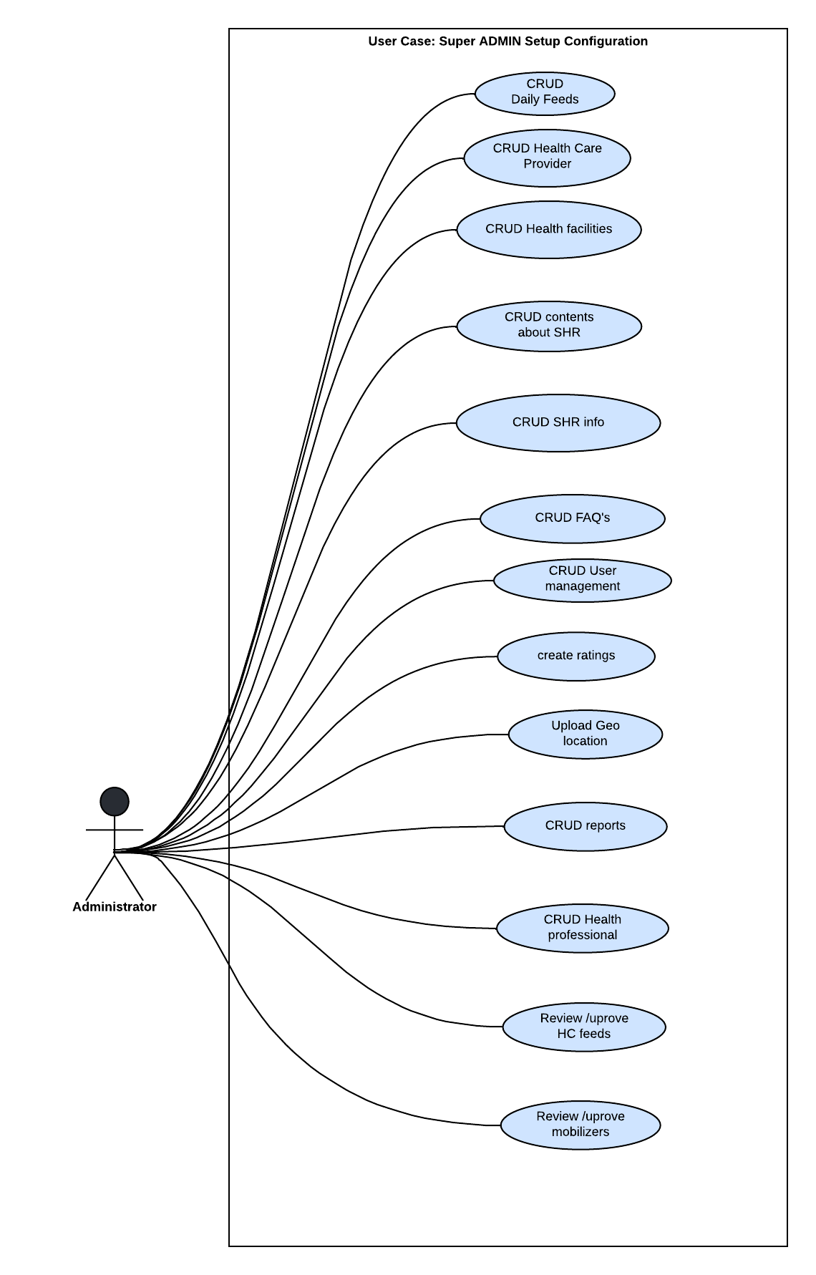

Figure 3: Super Admin use case diagram

### 3.3.1.2 Admin setup use case diagram

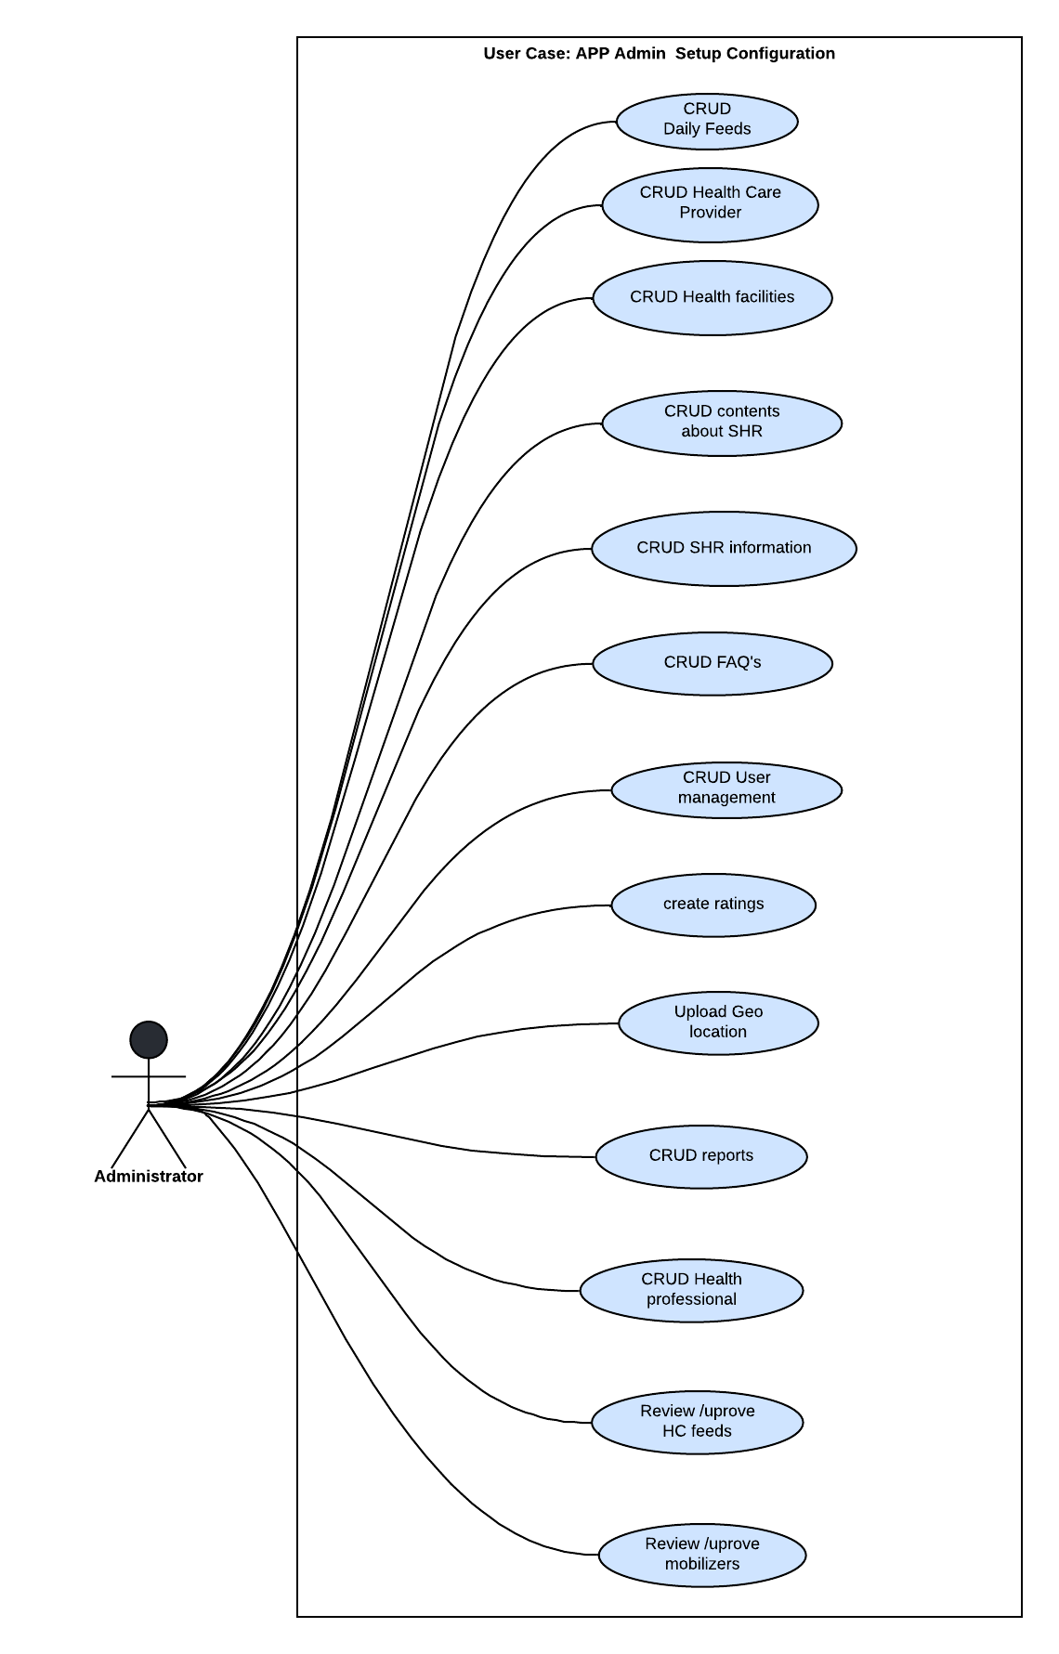

Figure 4: Admin use case diagram

### 3.3.1.3 Client use case diagram

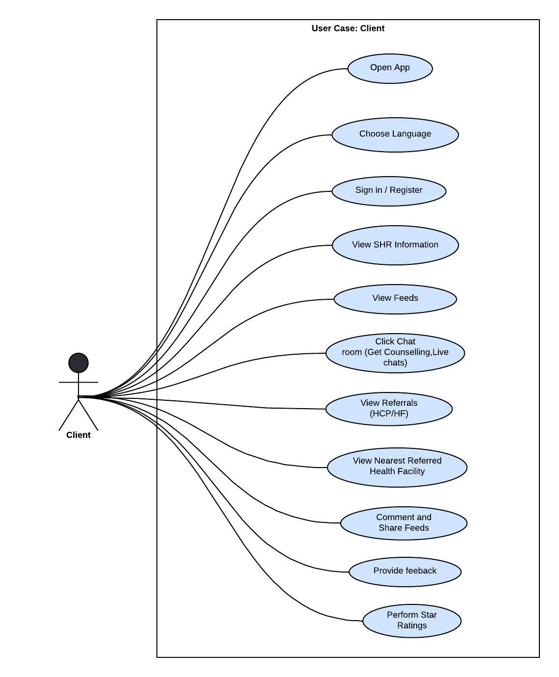

Figure 5: Client use case diagram

### 3.3.1.4 Health Care provider use case diagram

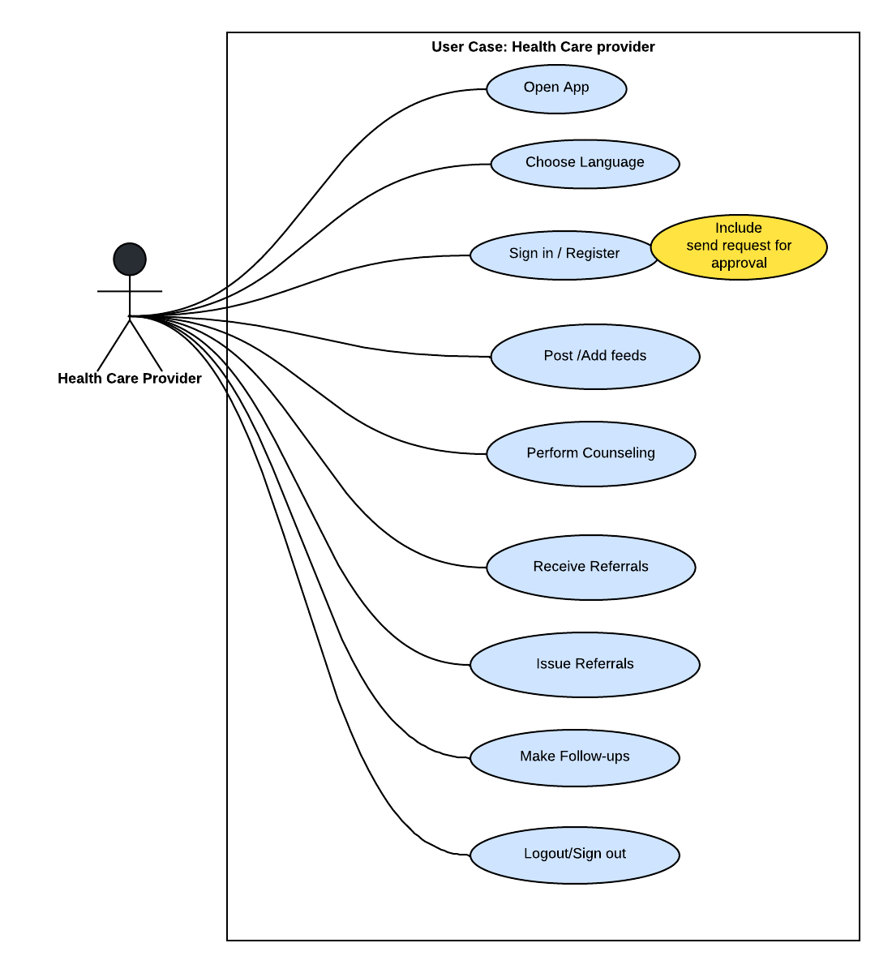

Figure 6: Health Care provider use case diagram

### 3.3.1.5 Community based mobilizer use case diagram

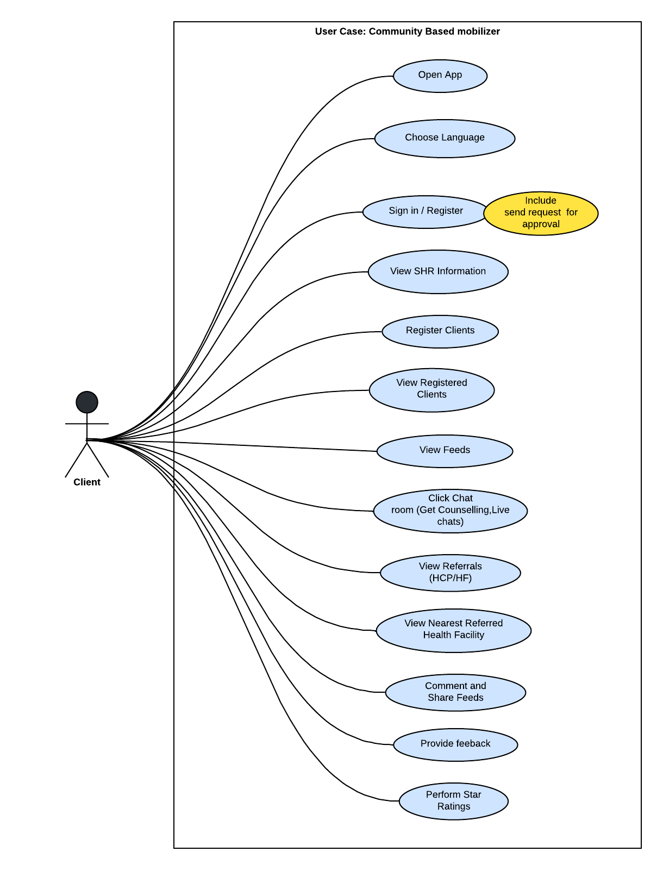

Figure 7: Mobilizer Use case diagram

### **3.3.2 Activity Flow Diagrams**

Activity diagram is used to display the sequence of activities. Activity diagrams show the workflow from a start point to the finish point detailing the many decision paths that exist in the progression of events contained in the activity. They may be used to detail situations where parallel processing may occur in the execution of some activities as shown in this section

### 3.3.2.1 Super Admin Activity Diagrams

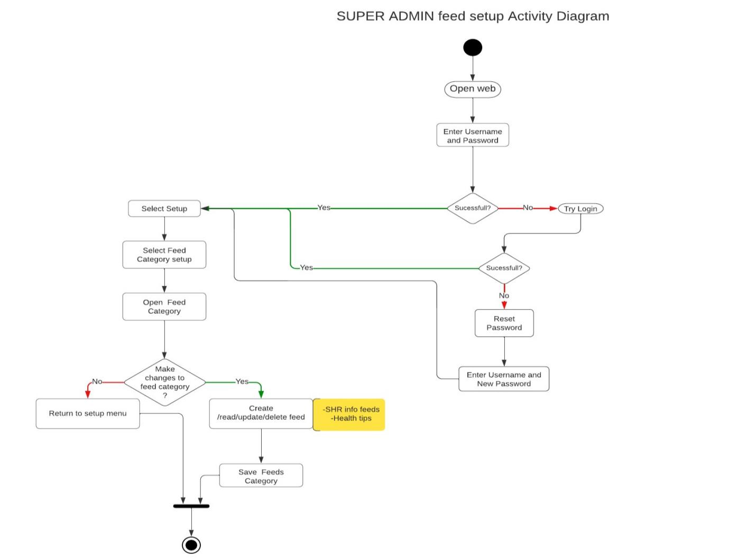

Figure 8: Super Admin feed configuration setup

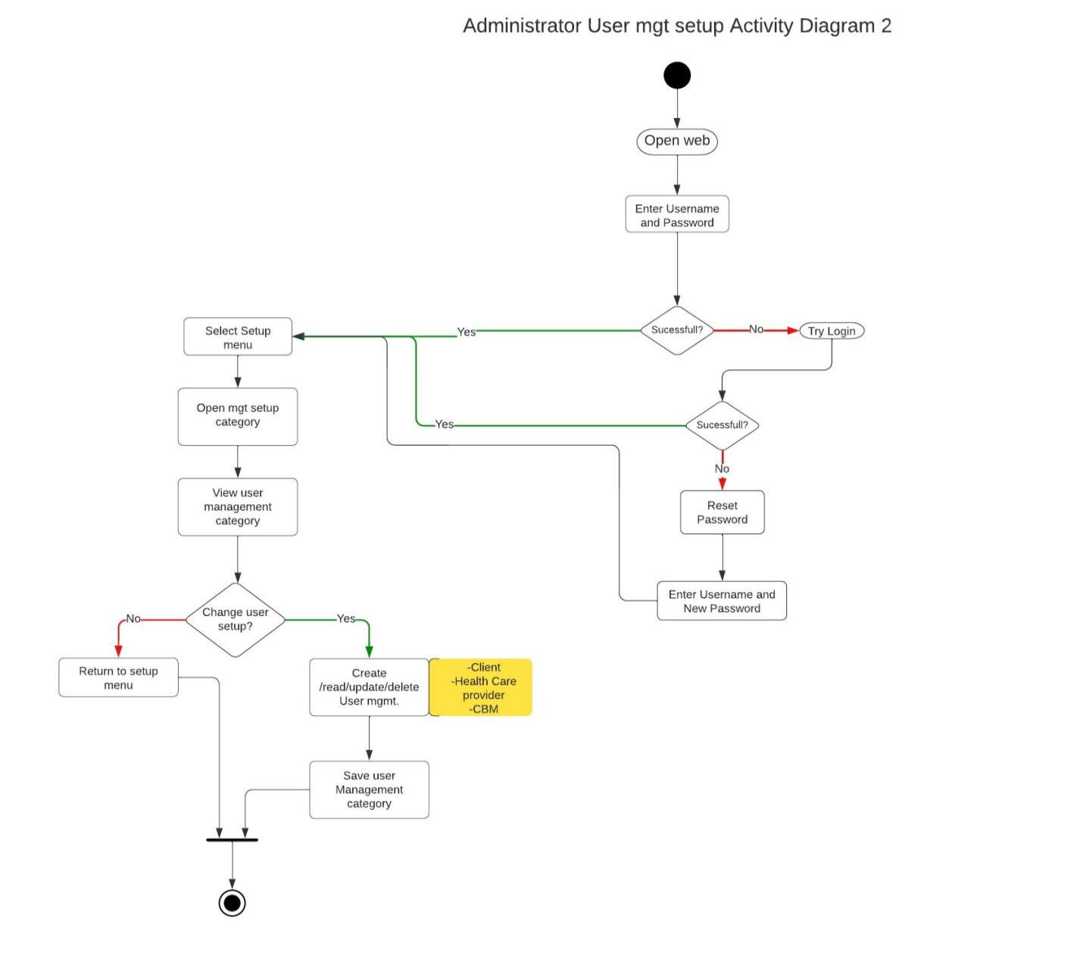

Figure 9: Super Admin user management configuration setup

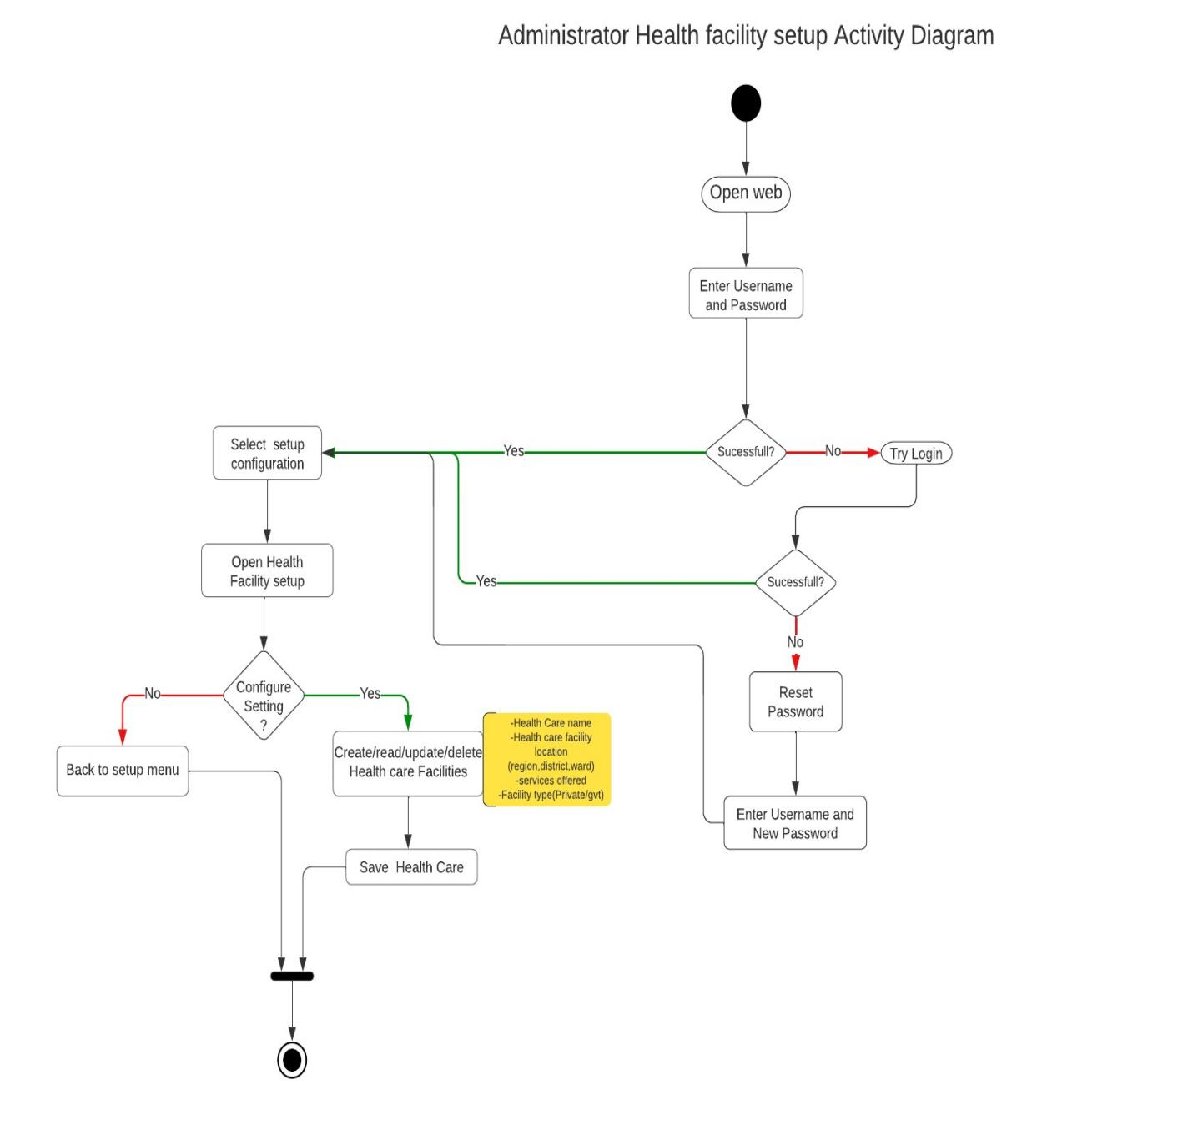

Figure 10: Super Admin Health Facility configuration setup

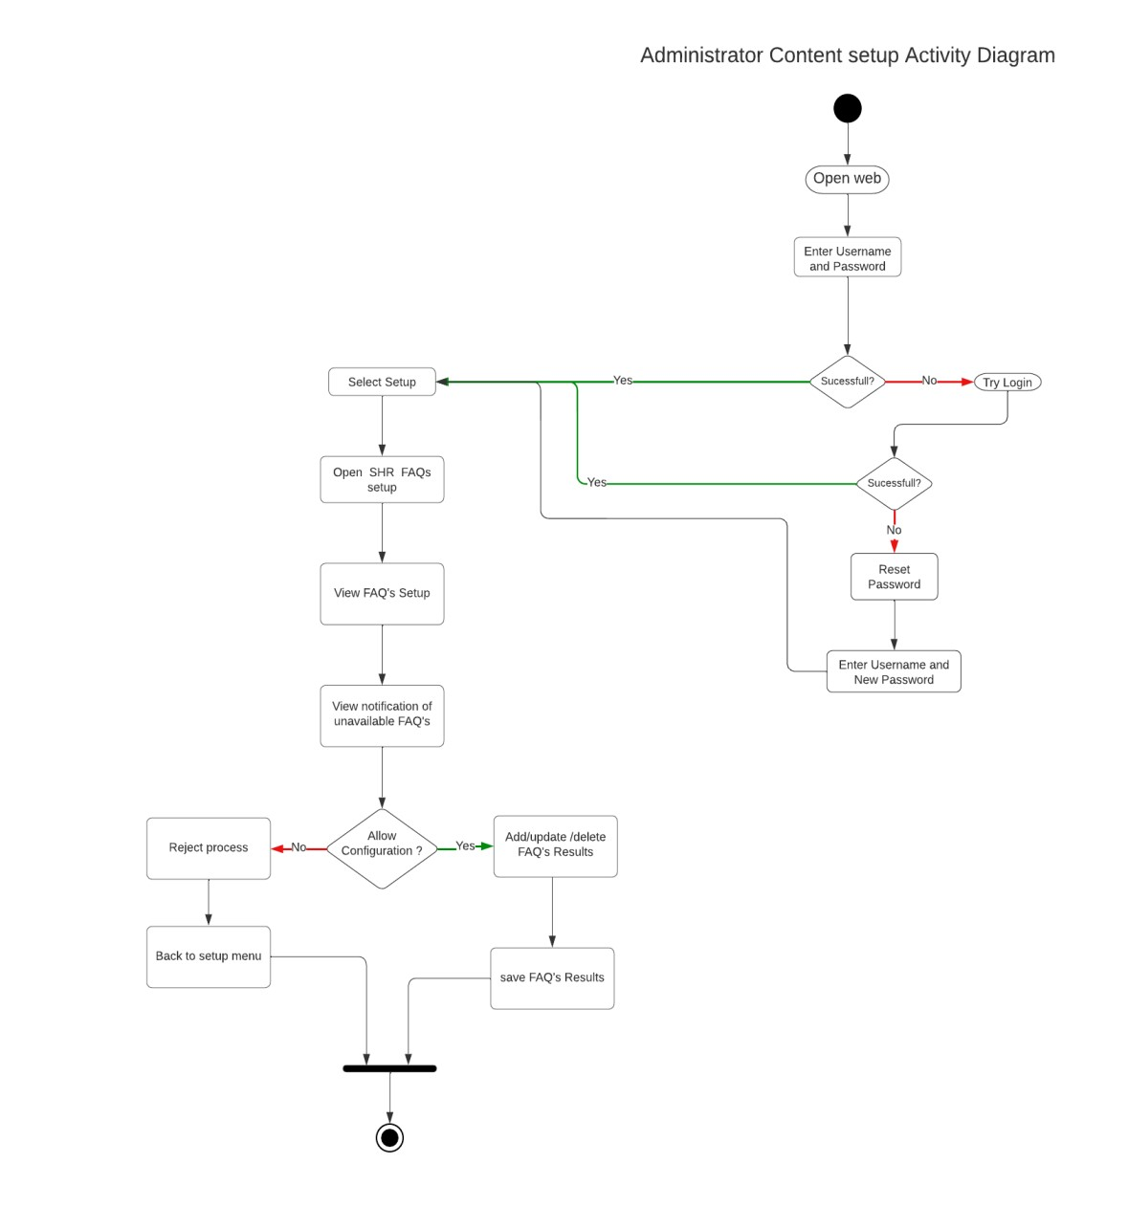

Figure 11: Super Admin Content configuration setup

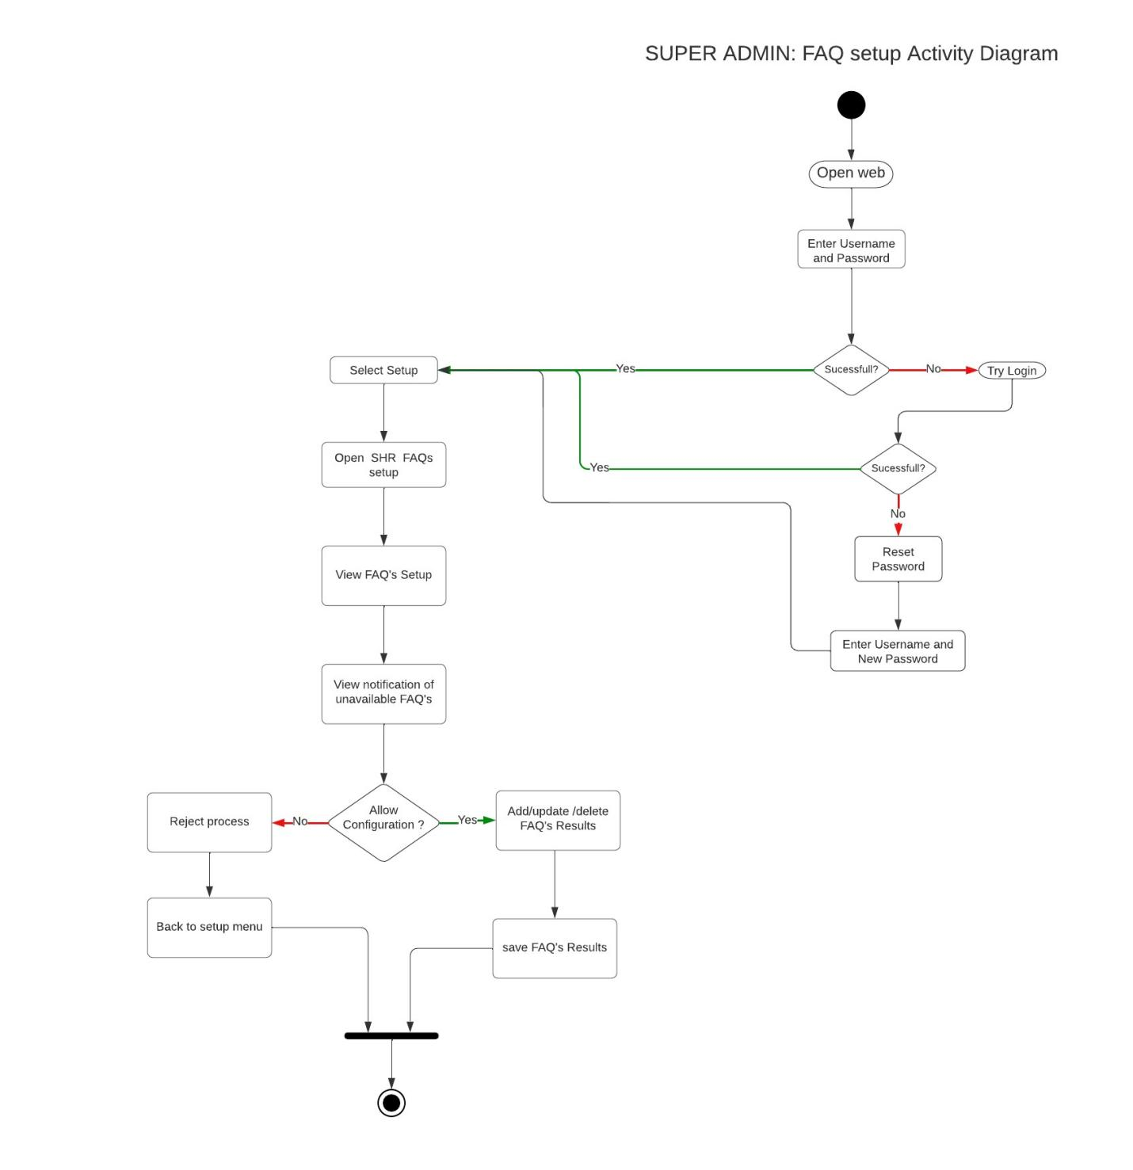

Figure 12: Super Admin FAQs configuration setup

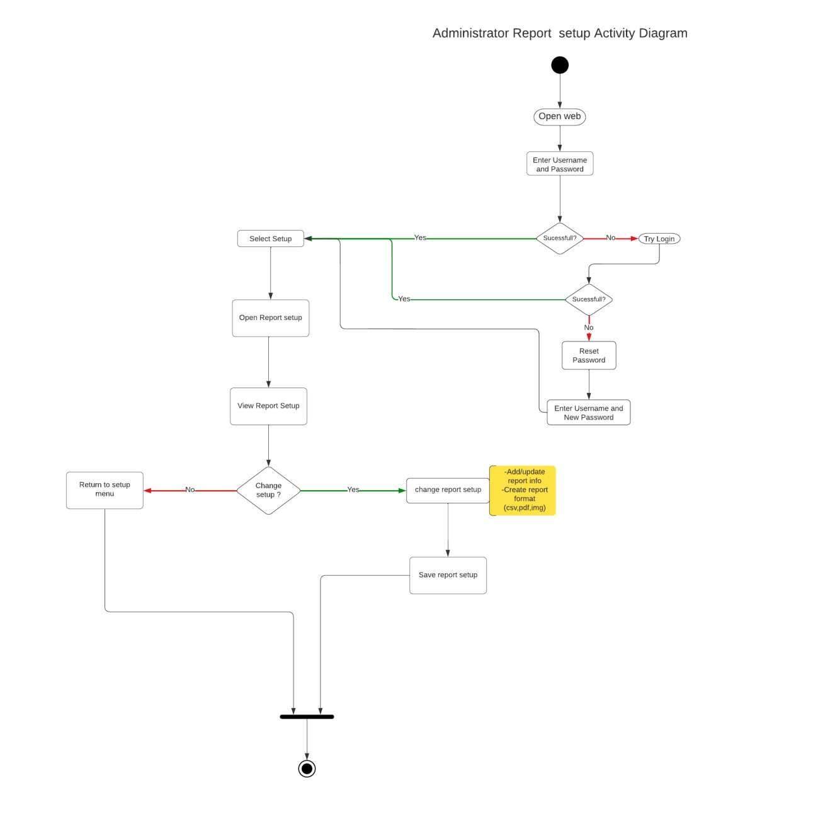

Figure 13: Super admin report configuration setup

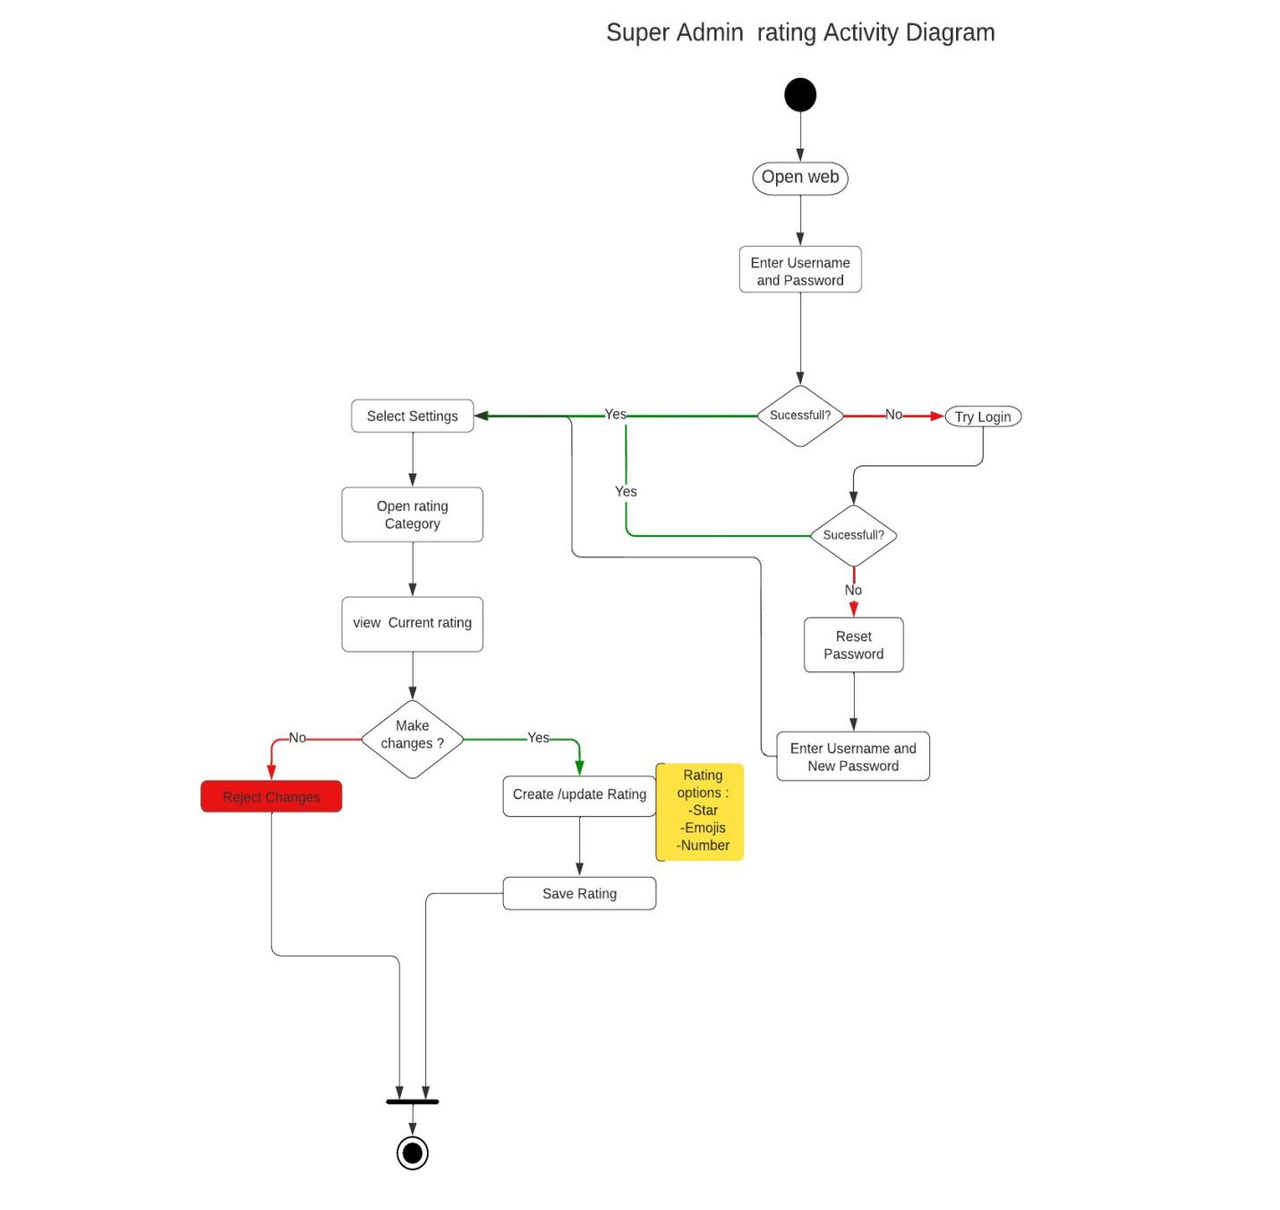

Figure 14: Super Admin rating configuration setup

### 3.3.2.2 App Admin Activity Flow Diagrams

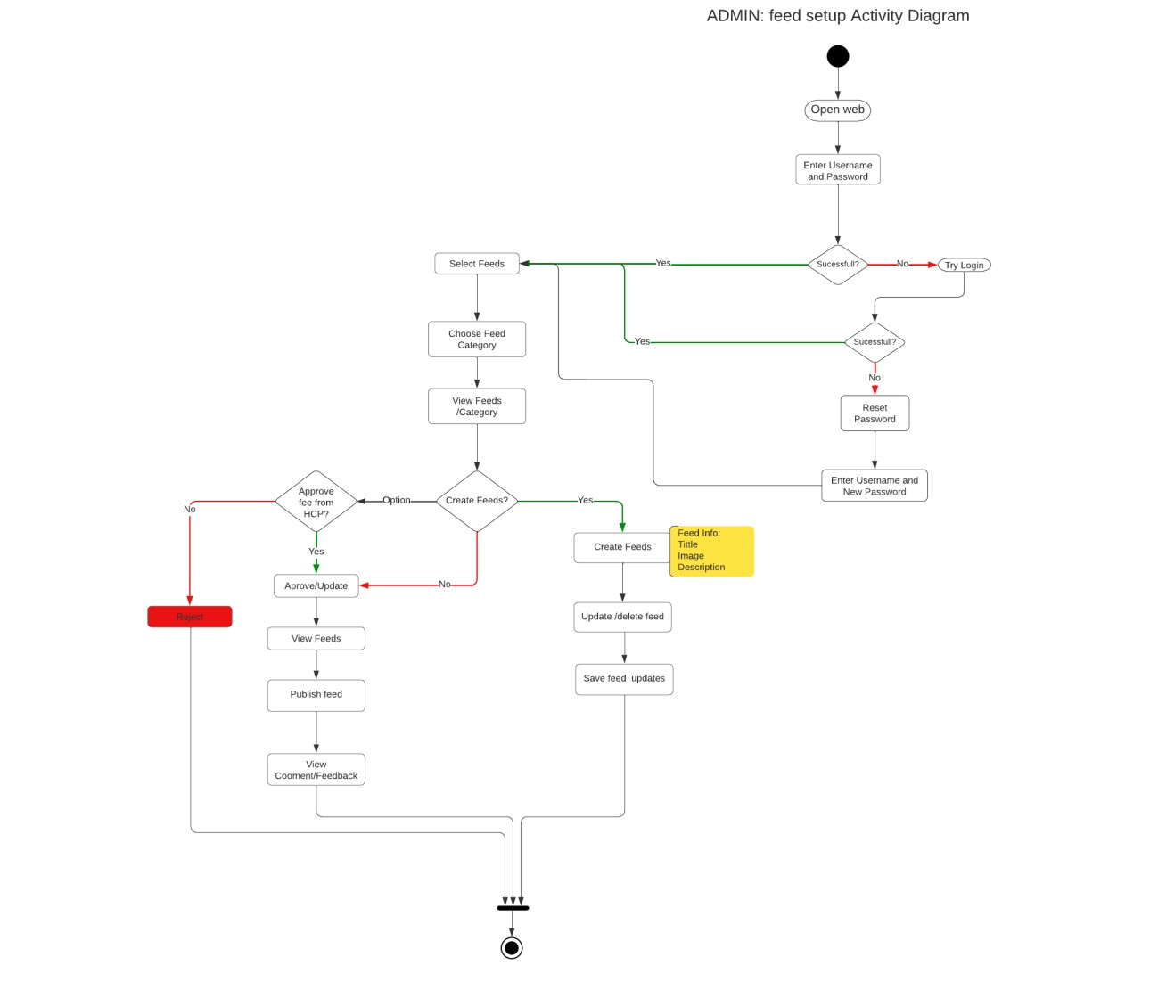

Figure 15: App Admin Feed setup configuration setup

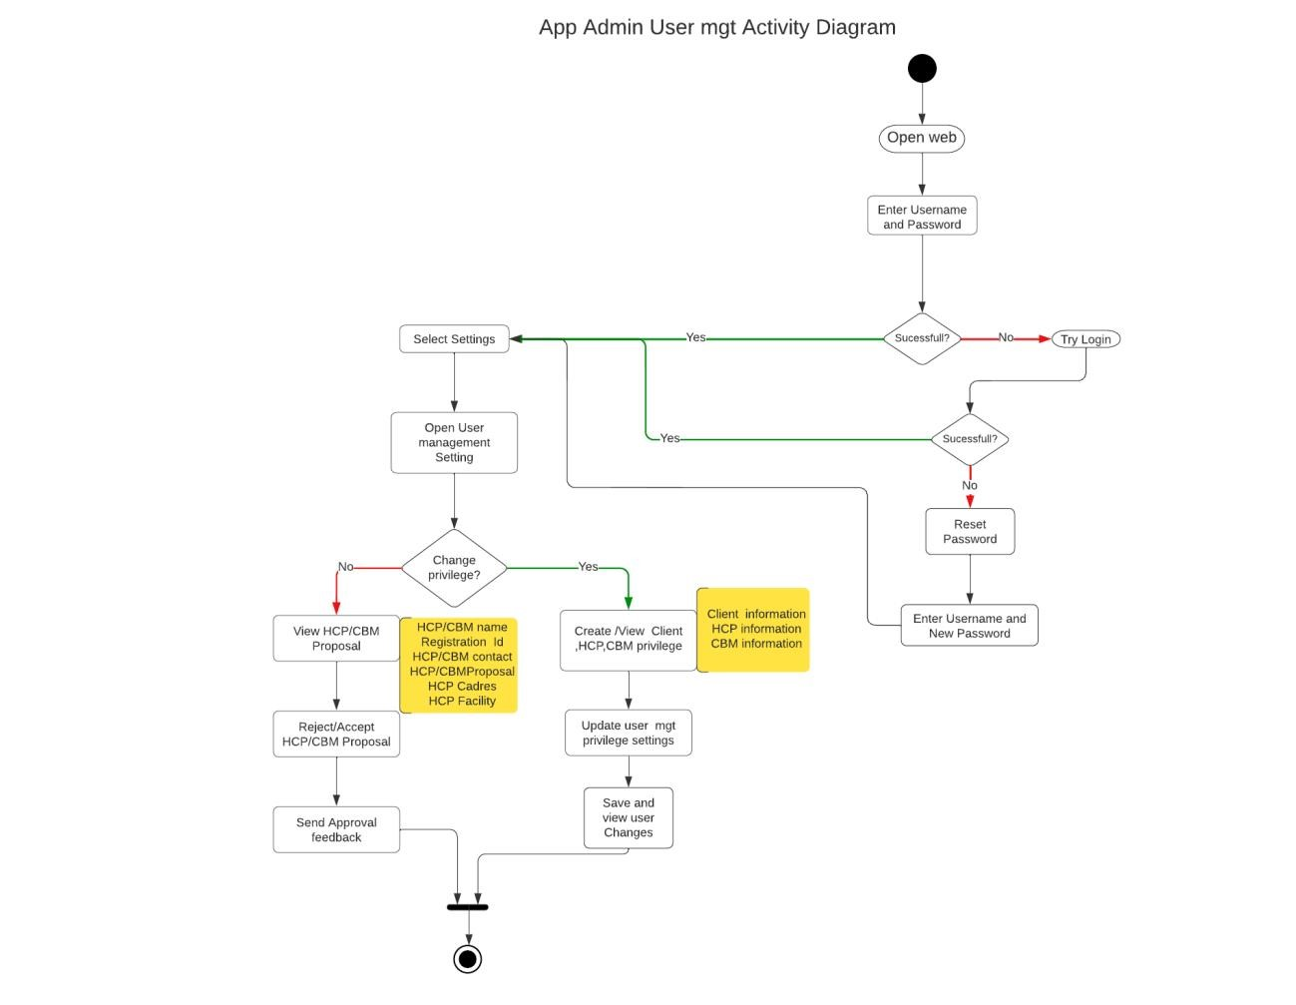

Figure 16: App admin user management configuration setup

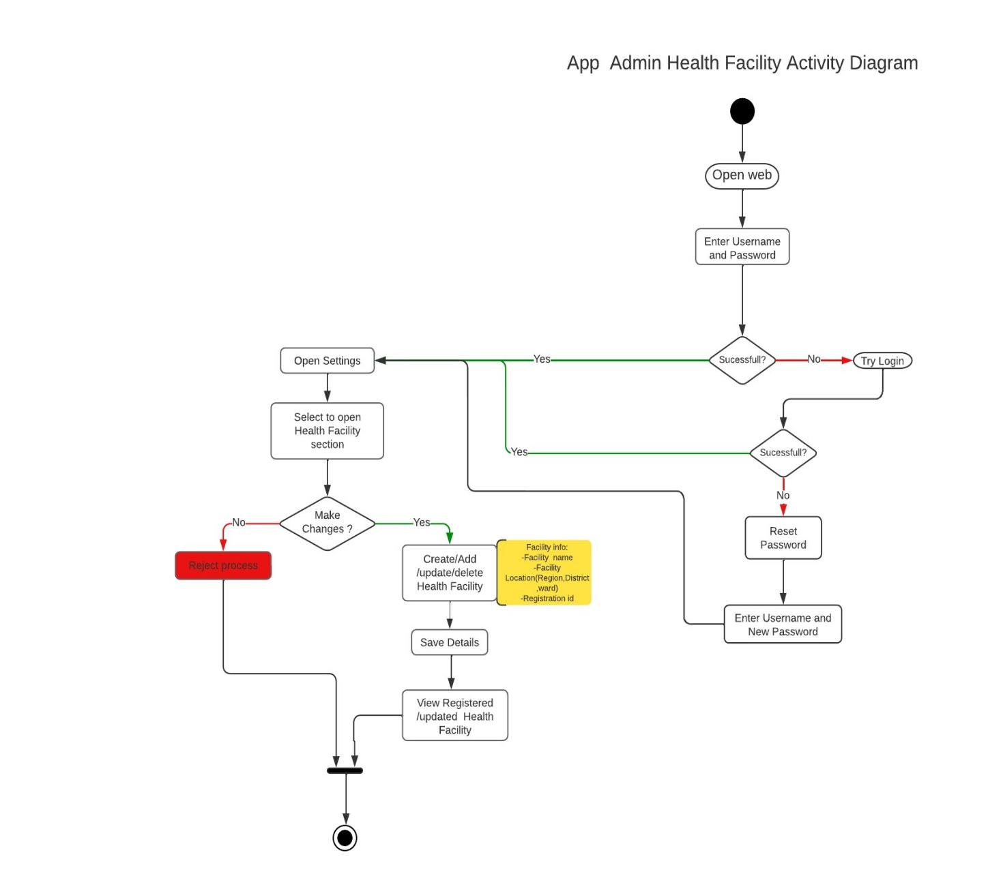

Figure 17: App admin health facility configuration setup

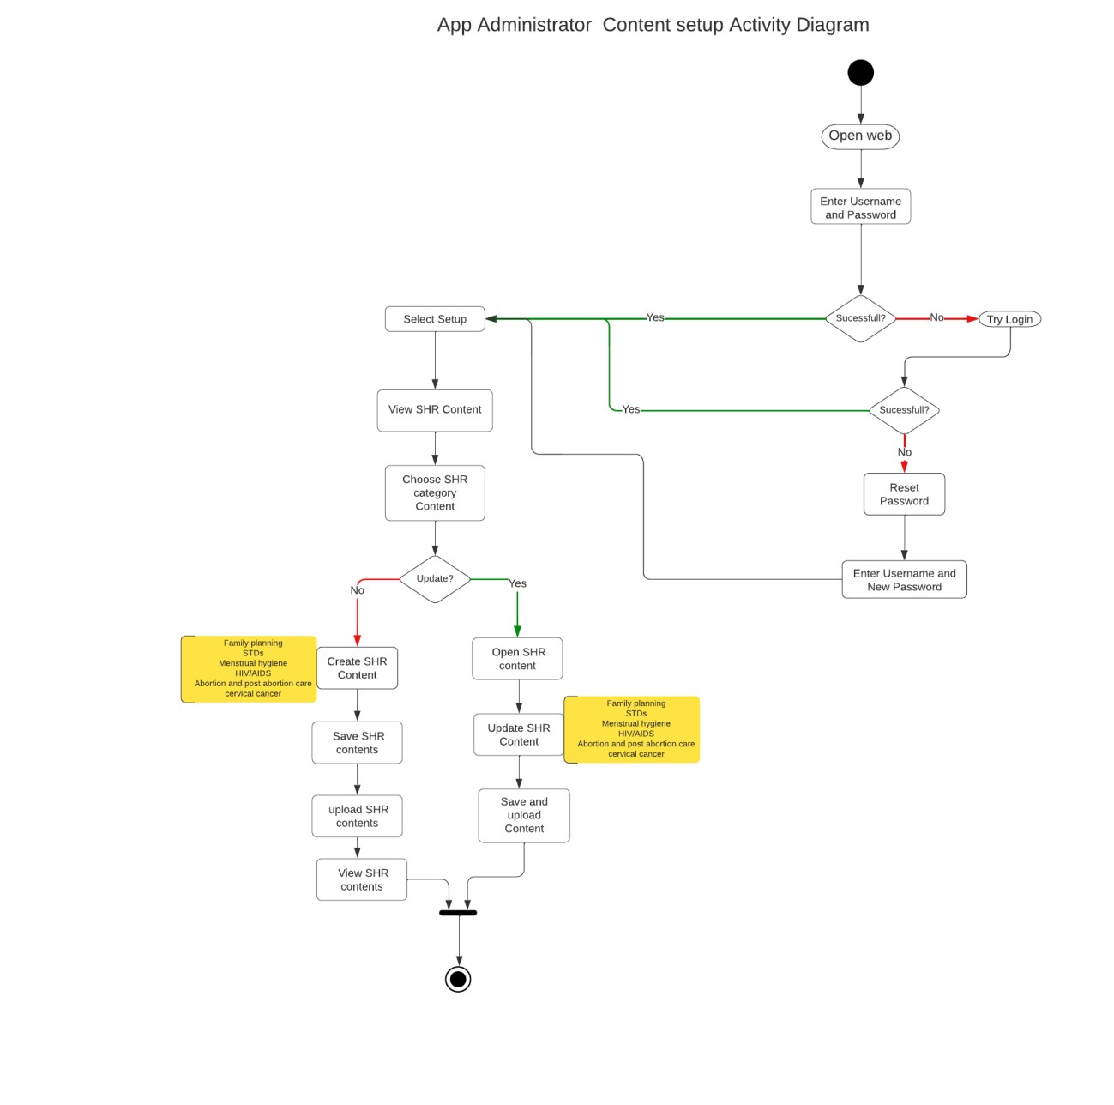

Figure 18: App admin configuration setup

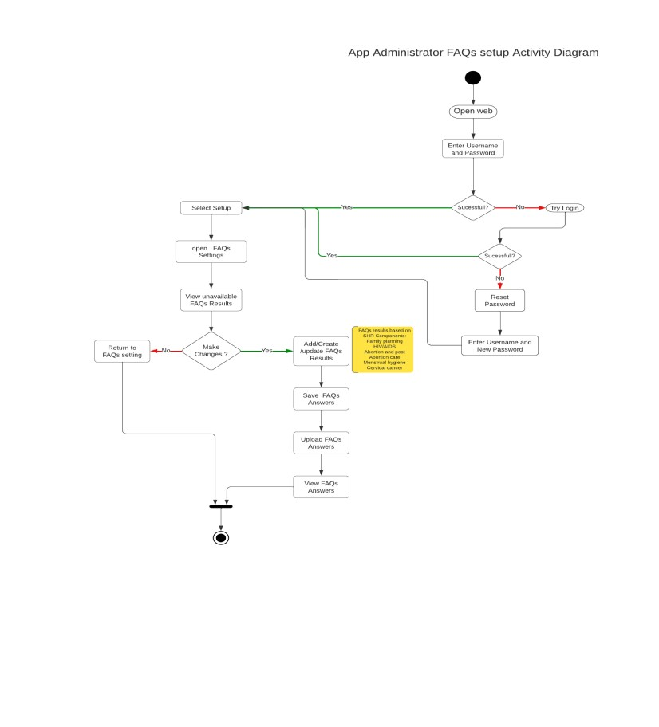

Figure 19: App admin FAQs configuration setup

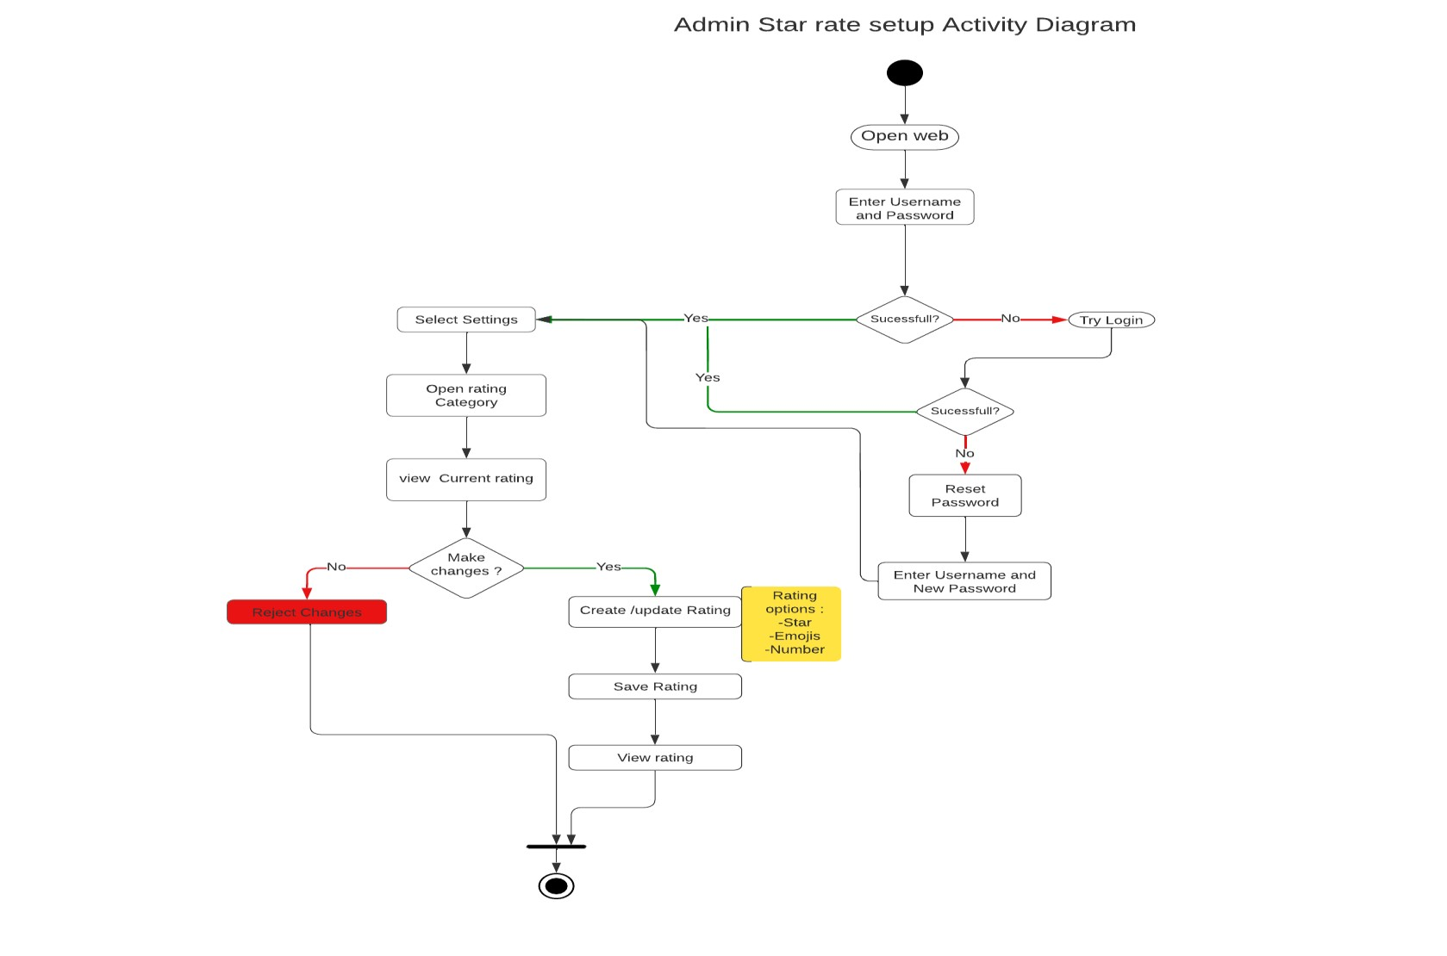

Figure 20: App admin rating configuration setup

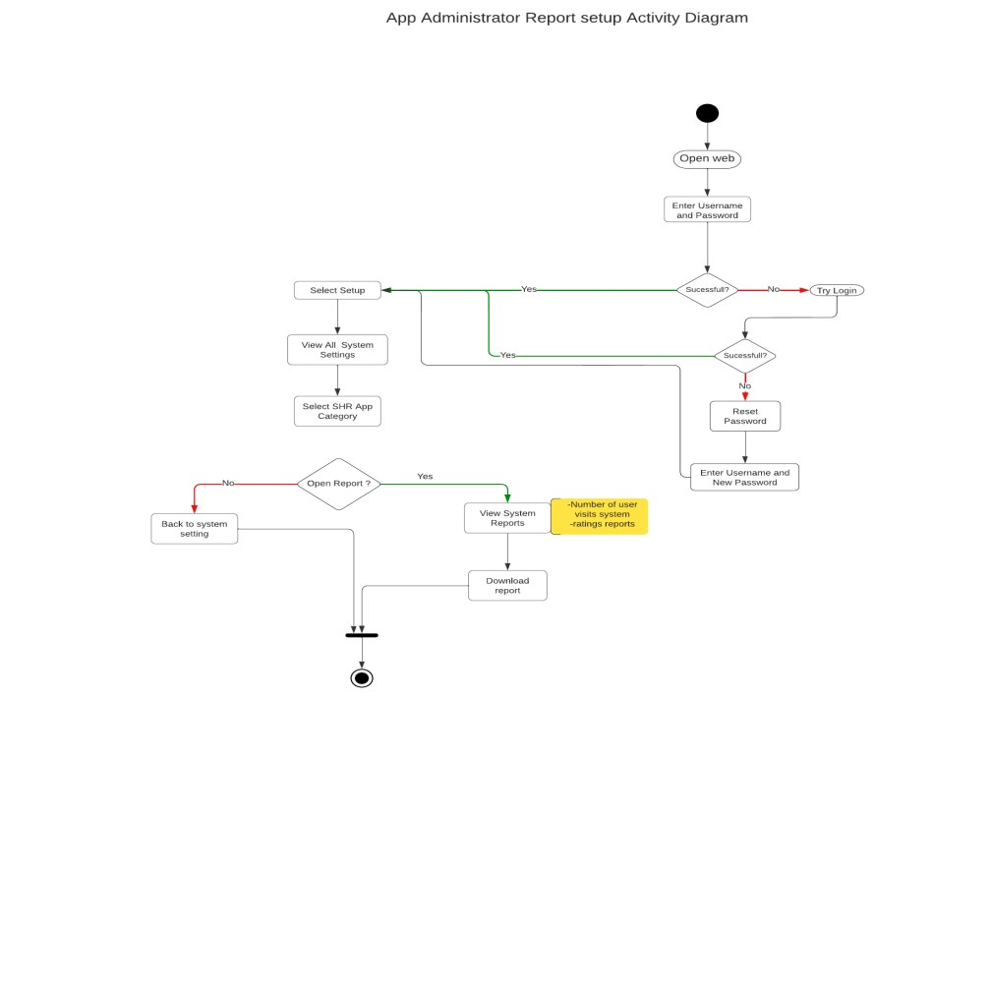

Figure 21: App admin report configuration setup

### 3.3.2.3 Client Activity Flow Diagram

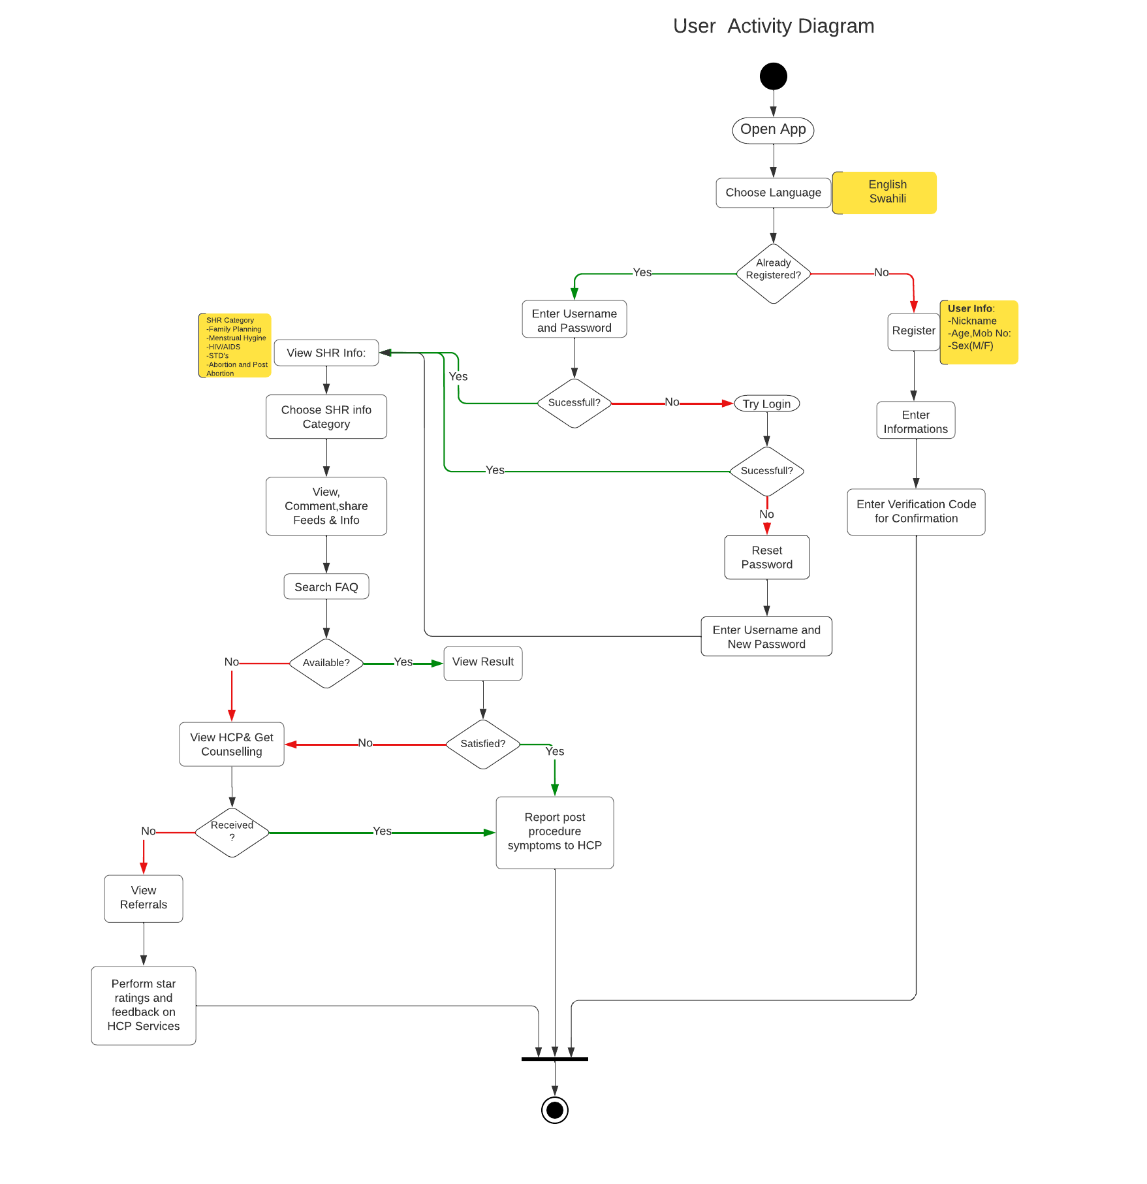

Figure 22: Client Activity Flow diagram

### 3.3.2.4 Health Care Provider Activity Flow Diagram

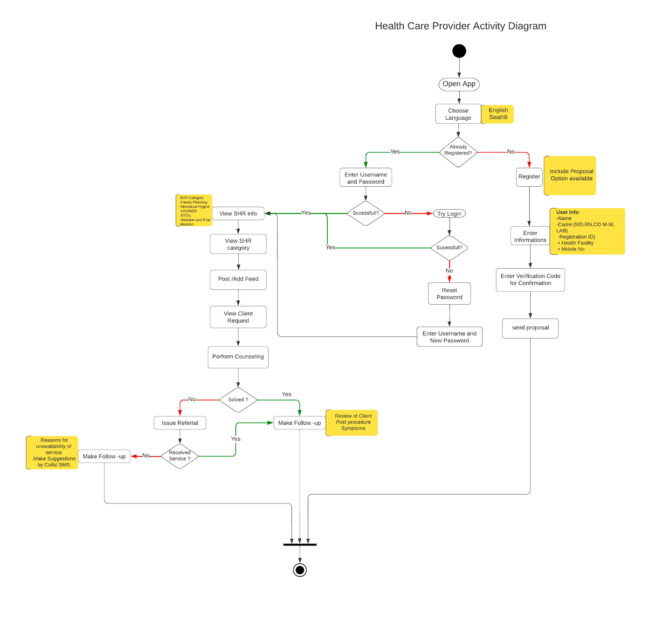

Figure 23: Health Care provider Activity diagram

### 3.3.2.5 Community Based Mobilizer Activity Flow Diagram

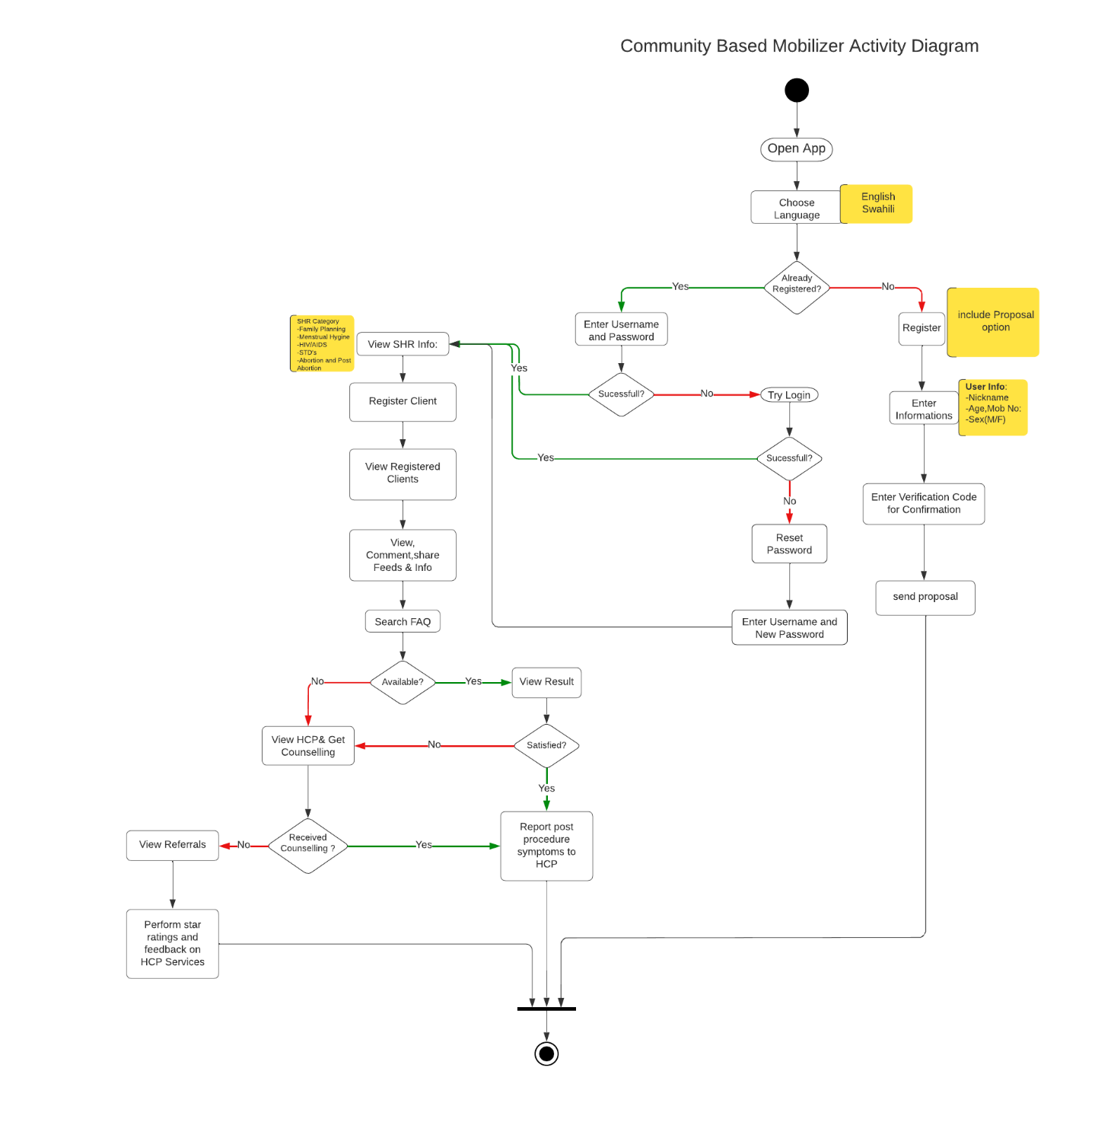

Figure 24: Mobilizer Activity flow diagram

### **3.4 User Interface design**

User Interface (UI) Design focuses on anticipating what users might need to do and ensuring that the interface has elements that are easy to access, understand, and use to facilitate those actions. This section consists of some of the user interface mock-ups designed for user to visualize how SHR App will be.

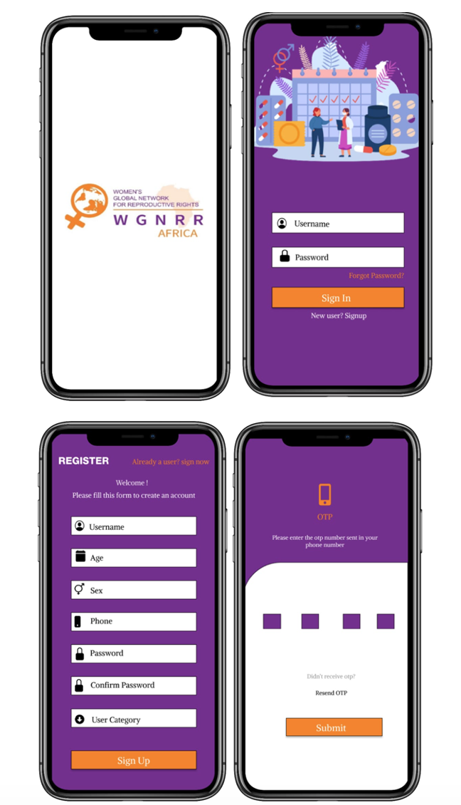 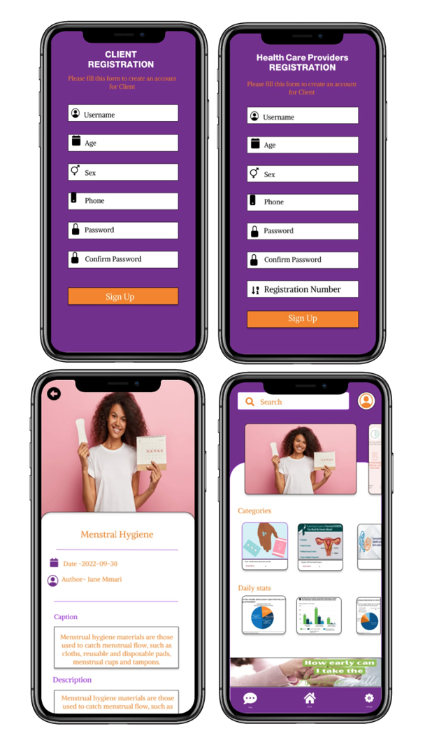

Figure 25: Sample User interface design on SHR App

3.4.2 Admin Side

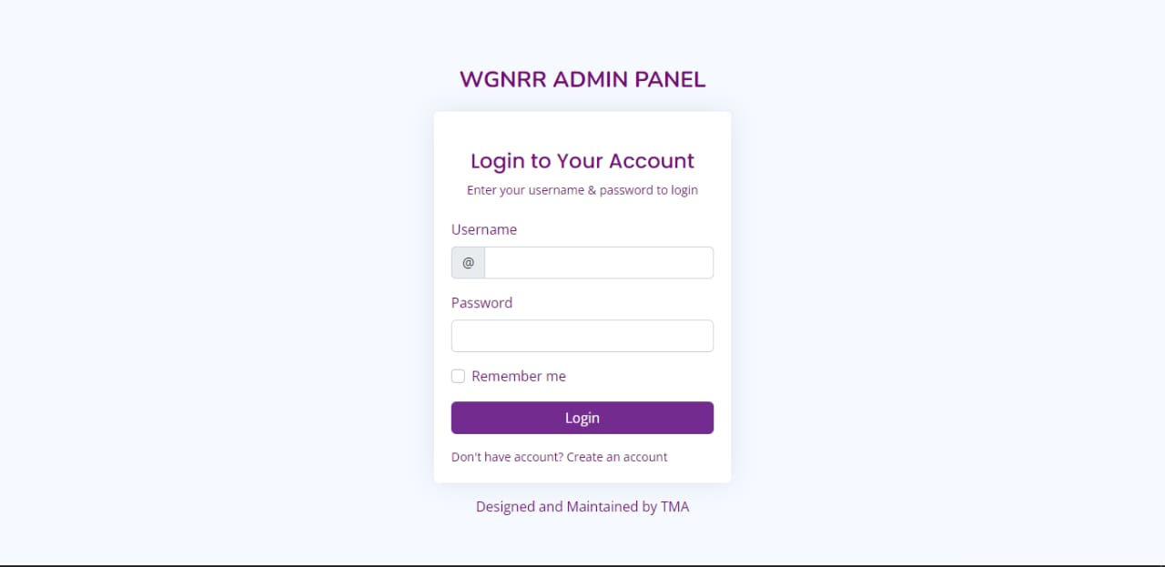

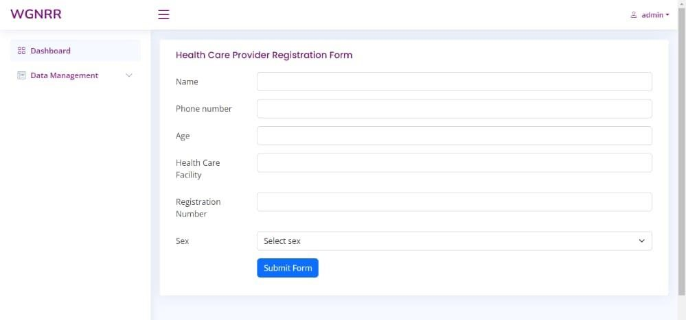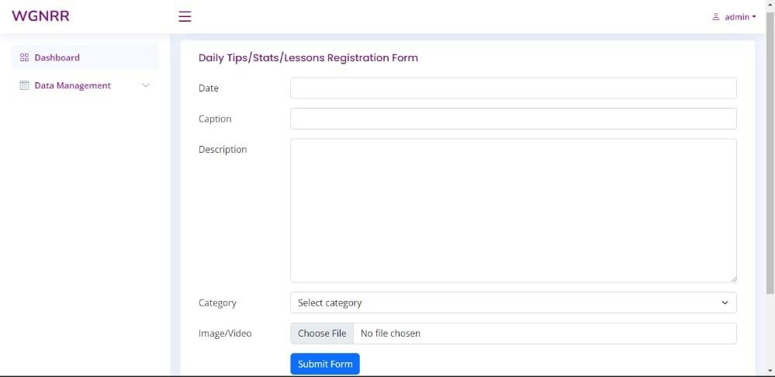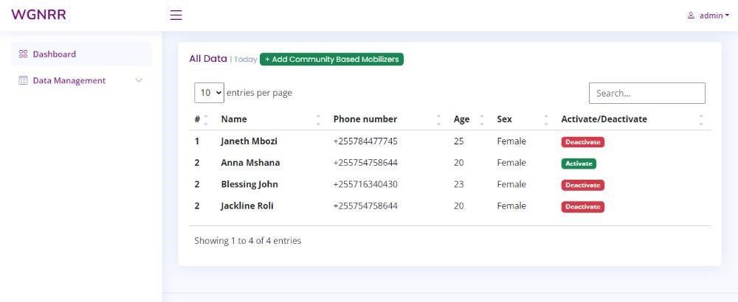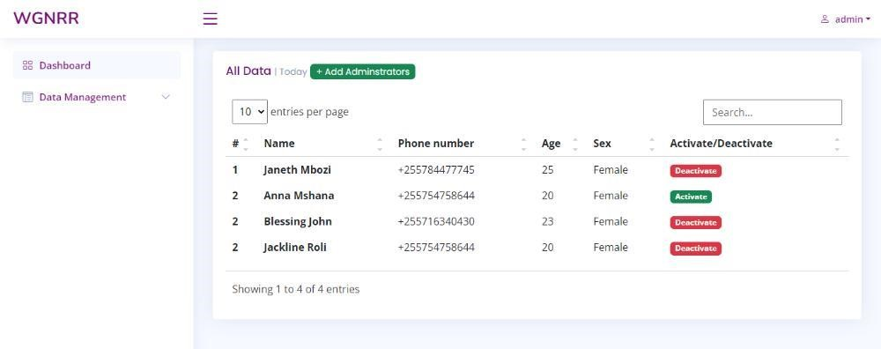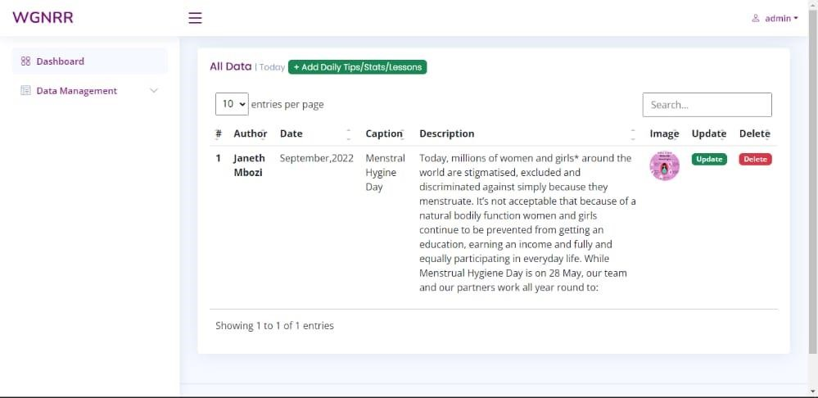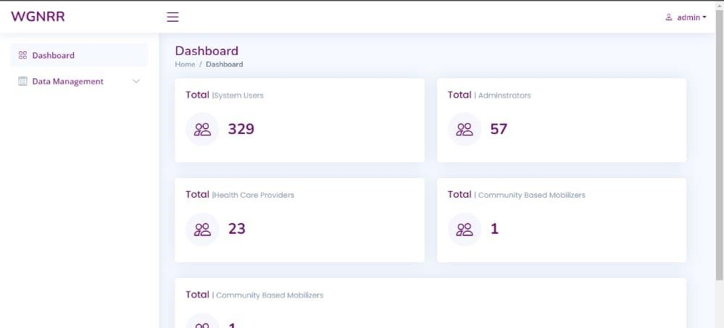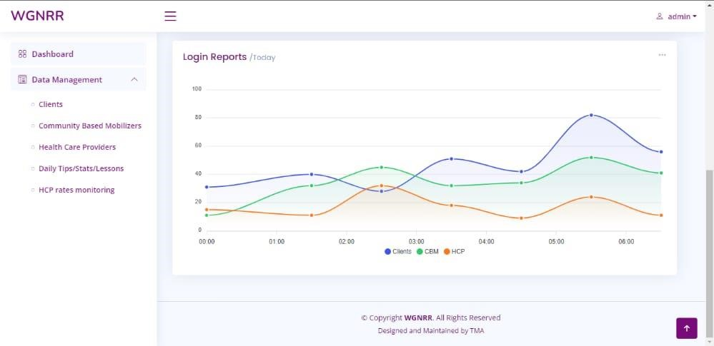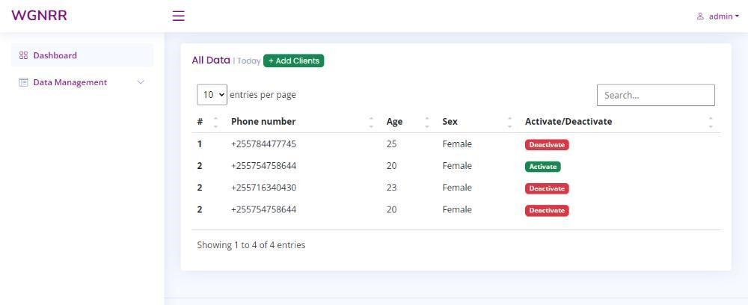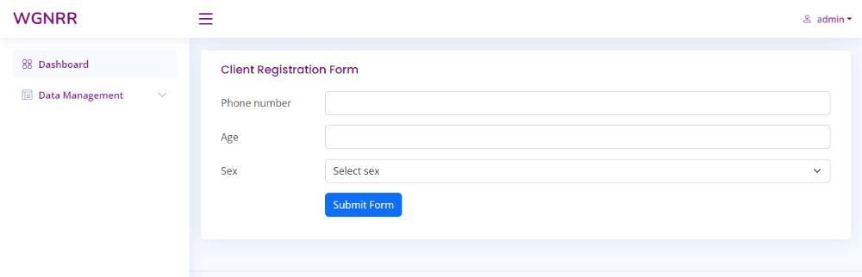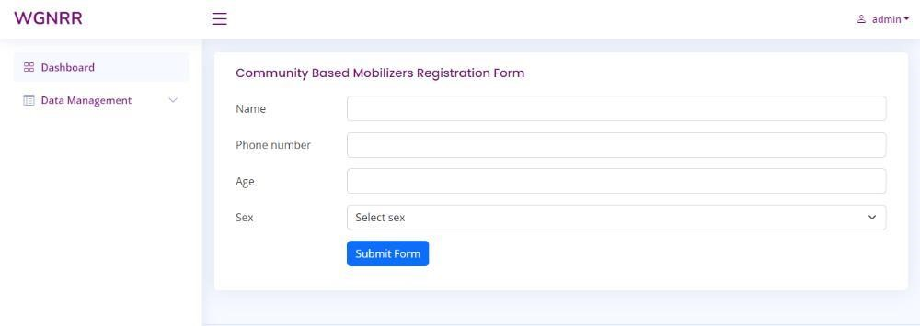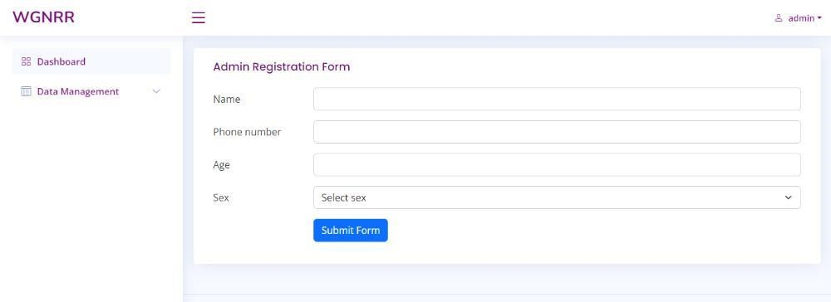

Figure 26: Admin Panel Interface design on SHR App

### **3.5 Appendix C: Approval**

The undersigned acknowledge that they have reviewed the Database Design Document and agree with the information presented within this document. Changes to this Database Design Document will be coordinated with, and approved by, the undersigned, or their designated representatives.

|  |  |
| --- | --- |
| **Document Approved By** | **Date Approved** |
|  |  |
|  |  |
|  |  |
|  |  |